REMOTE DEBUGING ON TOMCAT AND ECLIPSE

# Setting up tomcat server

Ensure Tomcat is not running before making any changes.

Add the following in the first free line that’s not commented out to the file **tomcat\bin\startup.bat**:



For example from:

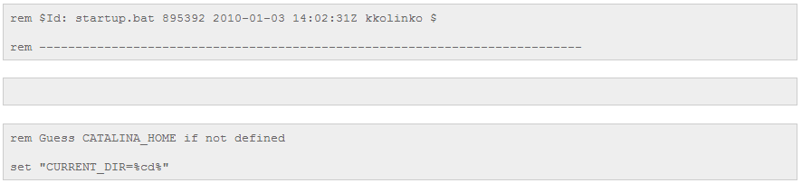

to:

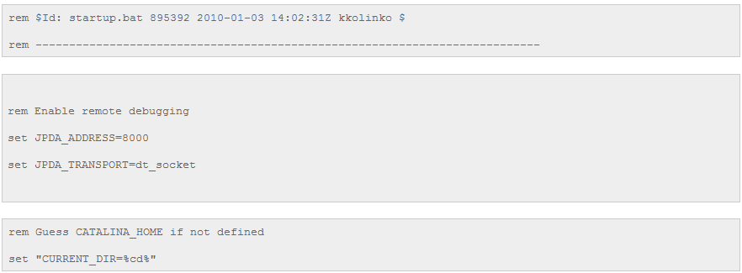

Modify the last line from



to



# Setting on Eclipse

Start Eclipse IDE.

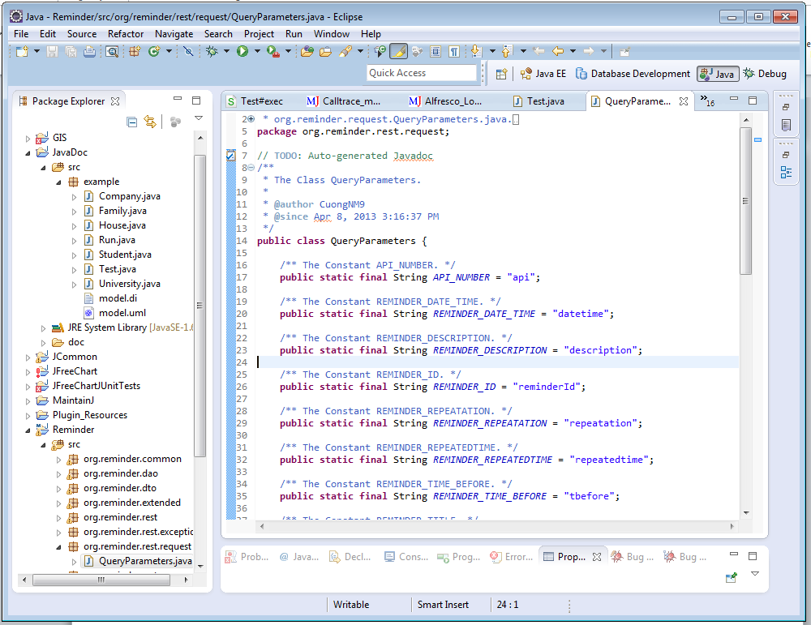

Go to **Run > Debug Configurations…**

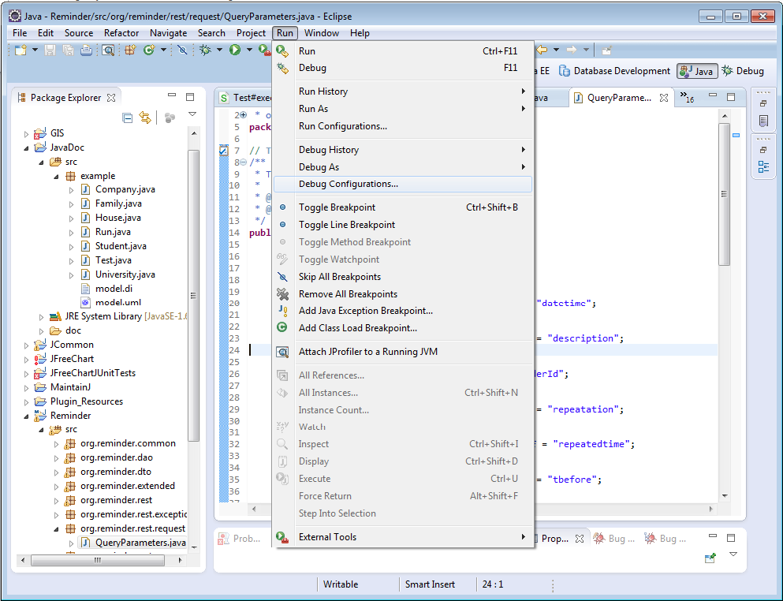

Right click on **Remote Java Application** from the menu on the left and select **New**

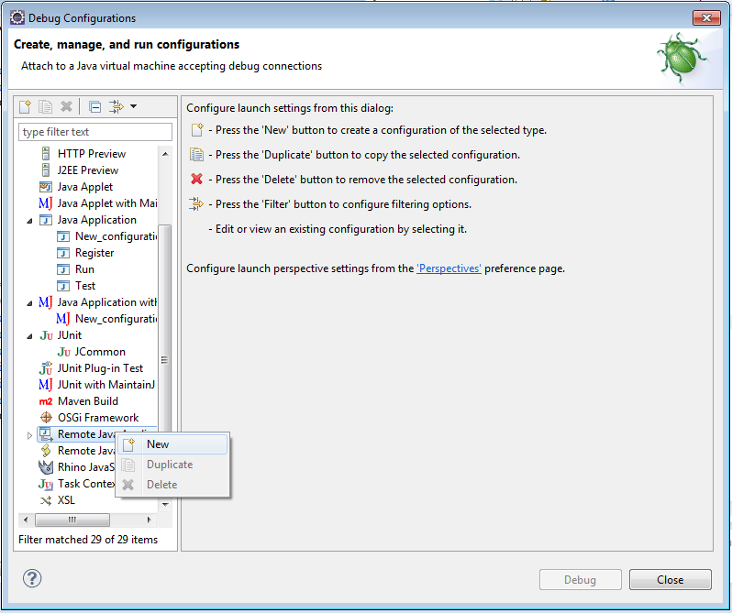

Enter the following:

* Name – A name for the configuration
* Project – Select a Java project to be associated with
* Connection Type – **Standard (Socket Attach)**
* Host – IP address of the server. Use localhost if it’s running on the same computer
* Port – **9000** (any port you like, default is 8000)

Click the **Apply** button to save it. Press the Close button to make the dialogue disappear.

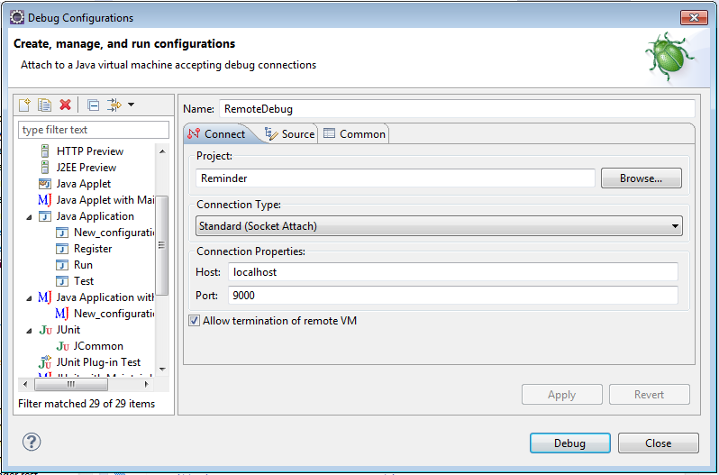

After that, if you want to run remote debug just click on debug button and select name of debug configuration you set. Remote debug look like:

